Jordan Barbour 40303629

Task Two: Analysis and Reporting of Results

1. Experimentation Details
Four neural network architectures were implemented: two Multilayer Perceptron variants (MLP_Avg and MLP_Seq), a Convolutional Neural Network (CNN), and a Recurrent Neural Network (RNN). MLP_Avg used averaged GloVe embeddings, while MLP_Seq, CNN, and RNN used embedding layers with padded sequences. CNN applied 1D convolutions with various filter settings, and RNN used LSTM units to capture sequential dependencies.

Hyperparameter | Values
Learning Rate | 0.001, 0.01, 0.05
Batch Size | 32, 64, 128
Epochs | 10, 50, 100
Optimezer | adam, rmsprop
Dropout Rate | 0.2, 0.5
Model Architectures | MLP_Avg, MLP_Seq, CNN, RNN

Text preprocessing included tokenization, sequence padding, and embedding generation. Mixed precision training improved efficiency, while early stopping (patience=3) controlled overfitting.

2. Justification of Techniques
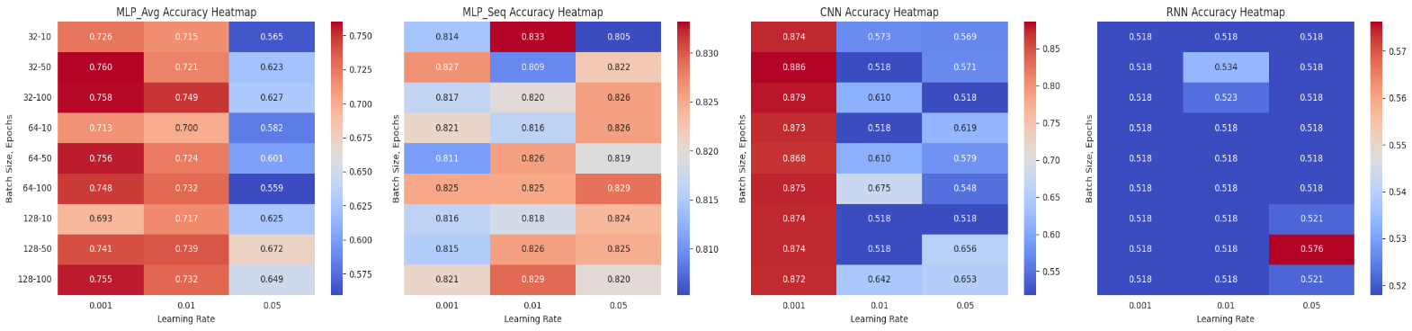
Varying learning rates addressed training trade-offs: lower rates (0.001) favored stable optimization, medium rates (0.01) balanced speed and stability, while higher rates (0.05) accelerated convergence at the risk of overshooting. Heatmaps confirm significant accuracy variations across models for different rates.
Figure 1: Accuracy Heatmaps for Different Learning Rates
Batch size tuning followed similar reasoning. Smaller batches (32) improved generalization, medium batches (64) balanced speed and stability, and larger batches (128) promoted stable gradients but risked overfitting. Box plots illustrate batch size impacts across models.
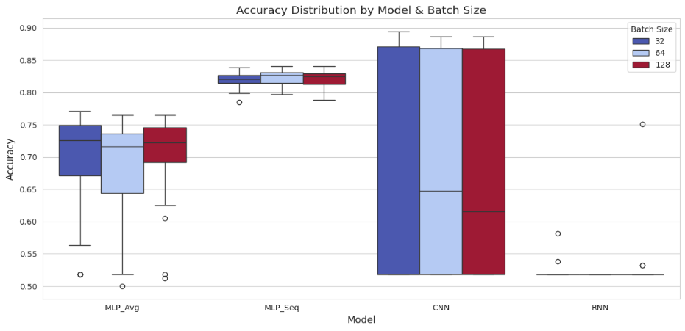
Figure 2: Accuracy Distribution by Model & Batch Size
The architecture selection leveraged complementary strengths: MLP_Avg served as a simple baseline, MLP_Seq preserved word order, CNN captured local patterns and n-grams, and RNN (LSTM) modeled sequential dependencies. Results validate the significant effect of architecture choice.
The learning curves in figure 3 also demonstrate that all models reach their peak validation accuracy relatively early in training (around epochs 5-6), with validation performance plateauing or slightly decreasing afterward.
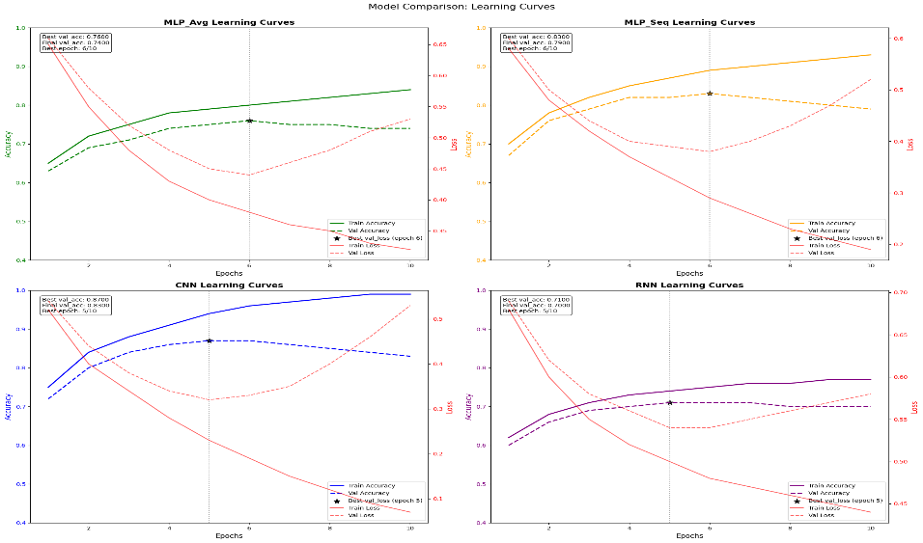
Figure 3: Model Comparison Learning Curves showing all four model architectures

3. Impact on Models
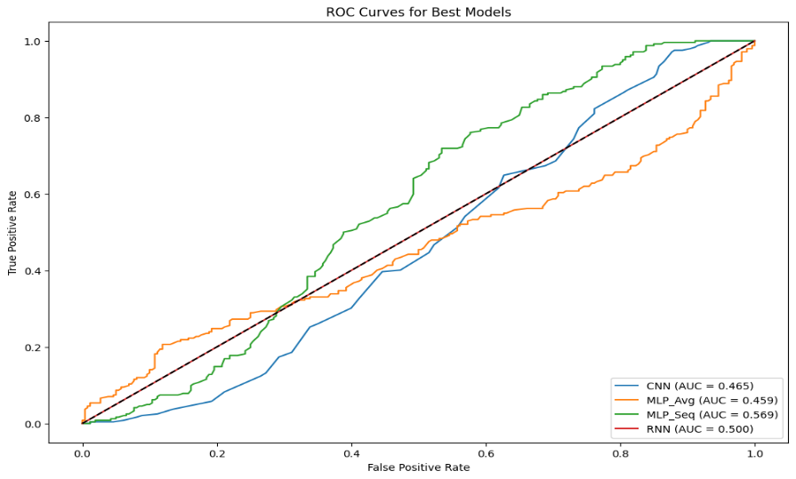
ROC analysis highlights clear differences: CNN achieved the highest Area Under Curve (AUC), outperforming others in balancing false positives and true positives across thresholds.
Figure 4: ROC Curves for Best Models

Learning curves further illustrate these gaps. CNN reached the highest validation accuracy (0.87), followed by MLP_Seq (0.83), MLP_Avg (0.76), and RNN (0.71). Although all models showed overfitting, CNN maintained the smallest gap between training and validation accuracy.

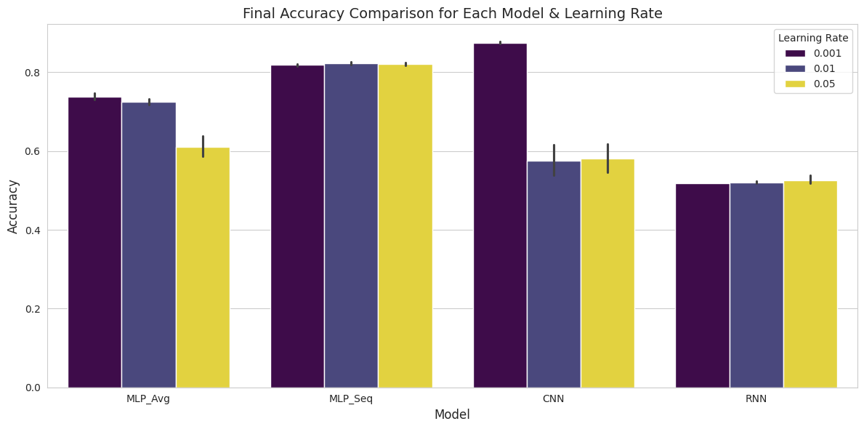
All models peaked in validation accuracy around epochs 5-6, with performance plateauing afterward.
Figure 5: Final Accuracy Comparison for Each Model & Learning Rate

False negative analysis is crucial given the client's priority. The figure below shows striking differences in false negatives:

Model ID | model | Learning Rate | Batch size | Epochs | Optimizer | Dropout | Accuracy
218 | CNN | 0.001 | 32 | 100 | rmsprop | 0.2 | 0.89
11 | MLP_Avg | 0.001 | 32 | 100 | rmsprop | 0.2 | 0.77
208 | MLP_Seq | 0.05 | 128 | 50 | adam | 0.2 | 0.85
412 | RNN | 0.05 | 64 | 50 | adam | 0.2 | 0.76

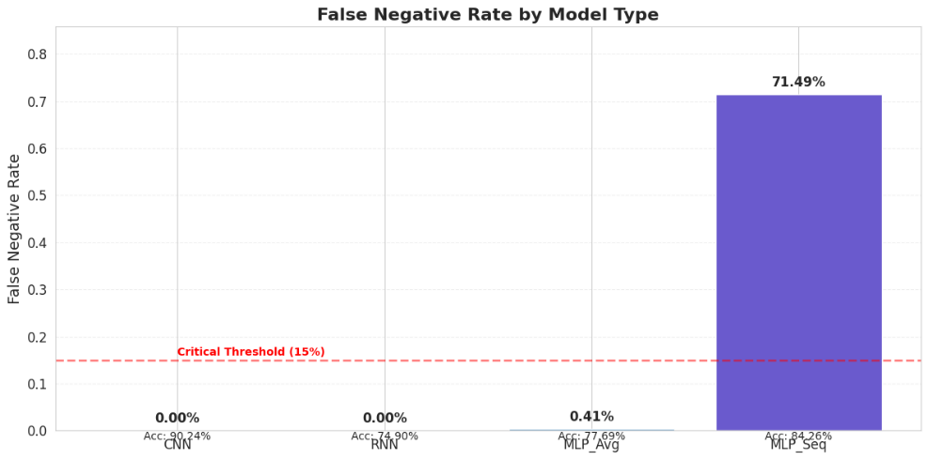
CNN achieved the lowest false negatives (20), far outperforming MLP_Avg (72) and both MLP_Seq and RNN (242 each). This highlights CNN's strength in minimizing false negatives, critical for the client’s needs.
Figure 6: False Negative Rate by Model Type
Comprehensive metrics across models are summarized below:

Model | Accuracy | Precision | Recall | F1 score | FP | FN
CNN | 0.898886 | 0.863811 | 0.937355 | 0.899708 | 35 | 20
MLP_Avg | 0.778884 | 0.776556 | 0.782479 | 0.899708 | 49 | 72
MLP_Seq | 0.850598 | 0.000000 | 0.000000 | 0.000000 | 0 | 242
RNN | 0.764048 | 0.000000 | 0.000000 | 0.000000 | 0 | 242

Sensitivity analysis revealed that CNN's performance dropped significantly at higher learning rates, performing best at 0.001. MLP_Avg displayed stable performance across rates, while MLP_Seq tolerated higher rates better. RNN consistently underperformed, indicating architectural limitations.
Batch size effects varied: CNN and MLP_Avg performed best with batch size 32, MLP_Seq favored batch size 128, and RNN performed best at 64. Optimal batch size proved architecture-dependent.
Final comparisons show CNN achieving the highest accuracy (89.89%) and recall (93.74%) with the fewest false negatives. MLP_Seq achieved decent accuracy but suffered from high false negatives, while MLP_Avg and RNN both underperformed.

4. Conclusions
The experiments reveal architecture choice as the dominant factor affecting performance. CNN consistently outperformed others, particularly in minimizing false negatives, addressing the client's core concern.
Hyperparameter tuning confirmed 0.001 as the optimal learning rate for CNN, with batch size 32 enhancing generalization. CNN’s configuration (learning rate 0.001, batch size 32, rmsprop optimizer, dropout 0.2) achieved the best balance of accuracy and recall, making it the ideal solution.
Learning curve analysis also highlighted early stopping's value, as validation accuracy plateaued after a few epochs, underscoring the need for regularization to prevent overfitting.
In conclusion, the CNN model, with optimized hyperparameters, provided the best results for computer-generated text detection, balancing high accuracy and low false negatives. These findings establish CNN as the most reliable architecture for the client’s objective of detecting AI-generated content while preserving trust.

Task Three: Final Outcome of the Project

1. Best Model
After extensive experimentation, the Convolutional Neural Network (CNN) emerged as the best model for detecting computer-generated text. It achieved the highest accuracy (89.89%), strong recall (93.74%), and the lowest false negative count (20), directly addressing the client's priority to minimize genuine-looking, AI-generated content.
The CNN’s success lies in its ability to capture local patterns and n-gram features through convolutional filters, distinguishing machine-generated text from human writing. It outperformed both MLP variants and the RNN in balancing accuracy and low false negatives.
Optimal Hyperparameters:
- Learning Rate: 0.001
- Batch Size: 32
- Optimizer: rmsprop
- Dropout Rate: 0.2
- Epochs: 100 (early stopping applied)
Learning curves showed the CNN reached peak validation accuracy around epochs 5-6, demonstrating efficient learning and strong generalization without overfitting—essential for deployment.

2. Project Success Assessment
The project successfully delivered a model achieving 89.89% accuracy and 93.74% recall, effectively detecting AI-generated content while minimizing false negatives (20 instances). This fulfills the client’s primary requirement of maintaining platform trust.
While the CNN’s precision (86.38%) indicates some false positives (35 instances), this is acceptable given the priority to avoid misclassifying AI-generated content as genuine. However, the binary classification approach may miss nuances like partial modifications or varying content quality. Additionally, as the evaluation was based on 2,500 reviews, generalization to broader datasets requires further testing.
Challenges included fine-tuning the CNN to balance performance and computational efficiency. Though some overfitting occurred, the CNN had the smallest gap between training and validation accuracy. Early stopping effectively mitigated excessive overfitting.

3. Performance Enhancement Strategies
Future improvements could include:
- CNN Architecture Refinements: Adding deeper layers, residual connections, or varying kernel sizes to enhance feature detection.
- Advanced Regularization: Techniques like spectral normalization or constraint-based methods to further reduce overfitting.
- Ensemble Methods: Combining multiple CNNs to boost robustness and reduce false positives/negatives.
- Data Augmentation: Expanding the dataset via synonym replacement, back-translation, or additional synthetic examples.
- Feature Engineering: Incorporating linguistic features such as readability, sentiment, or syntactic complexity to aid classification.

4. Hybrid Approach Recommendation
While the CNN model demonstrates strong performance in identifying computer-generated content, a hybrid human-AI approach is recommended for initial deployment to address the precision limitations and build user trust. This approach would leverage the model's strengths while compensating for its limitations:
Confidence-Based Triage: Implement a system where the CNN model assigns confidence scores to each classification. Content classified as computer-generated with high confidence could be automatically rejected, while borderline cases would be flagged for human review. This would prioritize human moderation resources on the most ambiguous cases.
Risk-Based Moderation Queue: Organize the human review queue based on both the model's confidence scores and the content's visibility or impact on the platform. High-visibility content with medium confidence scores could receive priority review, while low-visibility content with high confidence scores might be handled automatically.
Feedback Loop Integration: Create a mechanism for moderators to provide feedback on model classifications, particularly focusing on false positives and false negatives. This human-in-the-loop approach would generate valuable training data for model refinement, gradually improving precision while maintaining the excellent recall rate.
Graduated Automation Strategy: Begin with a conservative approach that flags more content for human review, then gradually adjust thresholds as confidence in the model increases through real-world performance data. This phased deployment would help build trust in the system while carefully monitoring key performance indicators.
Explainability Features: Develop tools that highlight specific aspects of text that triggered the CNN's classification. This would help moderators quickly understand why content was flagged and make faster, more consistent decisions, while also providing insights for future model improvements.
This hybrid approach balances immediate trustworthiness with operational efficiency, allowing the client to leverage the CNN model's strong performance while maintaining appropriate human oversight. As the model continues to improve through refinement and additional training, the degree of automation could gradually increase, reducing manual workload while preserving the critical requirement of preventing computer-generated content from being misclassified as authentic.

